

FS COI Sales order header and batch determination

Functional Design Specification

Document Version Number: 1.0

Page 1 of 7

Table of Contents
Table of Contents 2
1 Business Functionality Overview 3
1.1 Functional Specification Type 3
1.2 Business Functionality 3
1.3 Security Considerations 3
1.4 Business Dependencies 3
1.5 Business Criticality 3
1.6 Assumptions 4
1.7 Overall Business Flow Diagram 4
2 Enhancement 5
2.1 Process Flow Diagram 5
2.2 Enhancement Specifications 5
2.2.1 Trigger 5
2.2.2 Check if the sales order is relevant for the CGT patient materials scenario (ZVV_PARAM) 5
2.2.3 ZCOI field in the Order Header Data, Additional data B tab 6
2.2.4 Checksum 7
2.2.5 Sales Order Custom batch determination 7
2.2.5.1 Trigger for the batch determination at sales order 7
2.2.5.2 Batch search strategy 7
2.2.6 Final check on order save 7
2.2.7 Delivery creation 7
2.3 Error Handling Specifications 8
3 Related Documents 8
4 Document History 8
5 Appendix 8

Business Functionality Overview

Functional Specification Type

FS Type | Applicable
Reports
Interfaces
Enhancements | X
Forms
Workflows

Business Functionality

In order to guarantee the chain of identity there is a need to have the chain of identity field in all of the documents involved in the apheresis process.

The following URSs are relevant for this functional specification:

“Sales Order and FDP Delivery
- Create a Sales Order with the clinical site as ship-to address and the customers as the invoice-to address.
- The COI should be present in the Sales Order as custom field at header level.
- When the sales order is created before the FDP is received, update Sales Order with actual delivery qty after GR of the final product. Every batch will have its separate line in the Sales Order.
- Batch determination at line level will be done at the Sales Order level after the usage decision for the full process order has been taken, and based on the COI characteristic to ensure that the right batch is sent to the right clinic (ship-to)
- Number of Batches will be selected based on quantity at the Sales Order line.”
“Custom batch determination rules and control
- Custom batch determination in the Sales Order based on COI with Batch classification.
- First match should be COI, second is closest expiry date, third is oldest receipt date.”

This functional specification covers the logic for having the COI field populated at the sales order header. The batch determination and creation of delivery is covered in a separate FS.

Security Considerations

There are no special security considerations: restrictions based on transaction code and organizational data apply for the users authorizations concept.

Business Dependencies

Master data needs to be correctly maintained, including customer master data, material master and material and batch classes and characteristics.

Business Criticality

If COI should be entered and it is not entered, we are not able to report where the materials for a specific COI will or were shipped to.

Assumptions

It is taken as an assumption that the sales orders for the CGT patient material scenario will be created manually and through the transaction code VA01.

Overall Business Flow Diagram

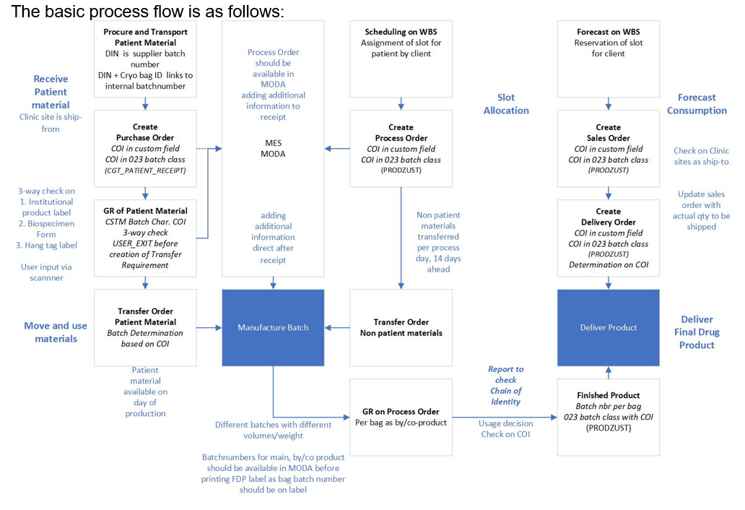
The Sales order may be created at any point in time of the process, i.e., before or after the creation of the process order. Multiple deliveries for one sales order, at different points in time are possible.
Sold-to-party and ship-to-party, including correct addresses, must be properly maintained (customer master data maintenance) before the sales order and delivery creation.

Process overview:
- Maintain customer master data (ship-to and invoice-to) in case there is a new customer of clinical site for shipment.
- Create sales order:
  - the user creates a Sales Order with the clinical site as ship-to address and the customers as the invoice-to address.
  - The system checks if the sales order is relevant for the CGT patient material scenario
  - If the sales order is CGT patient material relevant, the system checks is the materials entered are COI relevant and makes the custom field COI mandatory.
- Update Sales order:
  - The quantity in the sales order (and line items) can be updated/maintained by the user later (once the finished product is goods receipted against the process order).
  - The user triggers manual batch determination based on the COI characteristic.
  - The system validates the COI of the assigned batches.
- Create delivery:
  - The user manually creates the delivery(-ies) from the sales order.
  - On save we ensure that the COI of the batches in the delivery match the Sales order COI.
  - The COI is printed in the delivery documents.

Enhancement

Process Flow Diagram

- Sales Order Creation
- Sales Order is relevant for the CGT patient material scenario (check ZVV_PARAM)?
IF NO
Proceed with sales order creation
IF YES
Make field COI mandatory in tab Additional Data B
Validate COI by displaying checksum
Limit batches that can be assigned based on COI
- Sales order saved
- Proceed with Delivery creation process

Enhancement Specifications

Trigger

The enhancement should be triggered
- When the user initiates the creation of sales order (via VA01)
- When the user enters or changes materials assigned to the sales order
- When the user initiates saving of the sales order.

userexit_move_field_to_vbap may be used (after the user populates the material, the system stops in this user exit).

The following fields are relevant and need to be retrieved to perform the check:

Field Name | Data element | Retrieving logic
Sales document type (order type) | AUART | Entered by user on selection screen
Sales Organization | VKORG | Entered by user on selection screen
Material number | MATNR | Entered by user on sales order, item level
Characteristic value for “Hazardous class” | ATWRT | For MATNR, RCTAV-ATNAM=NL_HAZARDOUS_CLASS

Check if the sales order is relevant for the CGT patient materials scenario (ZVV_PARAM)

The conditions for triggering this enhancement are maintained in the ZVV_PARAM parameter table (Tcode ZVV_PARAM) with a new Lookup-Name (ZCOI_SO).

The sales order is relevant for the CGT patient material scenario and the enhancement is triggered if all conditions below are met:
- Order type XXXX /item category XXX
- Division?
- Sales organization is “0037” or “0036”
- Material Characteristic value for “Hazardous class” is 08 (for best performance, retrieve and check only when conditions 1 and 2 are met)

These conditions are maintained in the ZVV_PARAM table as below:
Lookup-Name (LOOKUP_NAME) | Freely Def. Key (FREE_KEY) | Free key Value (FREE_KEY_VALUE) | Indicator (INDICATOR1) | Value 1 (ZVV_PARAM- VALUE1)
ZCOI_SO | AUART | 001 | x | ZMO1
ZCOI_SO |  | 001 | x
ZCOI_SO | VKORG | 001 | x | 0037
ZCOI_SO | VKORG | 002 | x | 0036
ZCOI_SO | ATWRT | NL_HAZARDOUS_CLASS | x | 08

The program must be able to consider entering additional entries in the parameter table.

ZCOI field in the Order Header Data, Additional data B tab

The COI will be added as a new field to the sales order table (VBAK-ZCOI, CHAR30, same data element as AUKF-ZCOI).

The check is performed when the user enters a material number.

If ZCOI is relevant but empty after this check, the user should receive the error message:

“Sales order relevant for CGT process. Please populate COI field at header level.”

The system then should go to the ZCOI field in the order Header Data, “Additional data B” tab, so that the user can populate it:

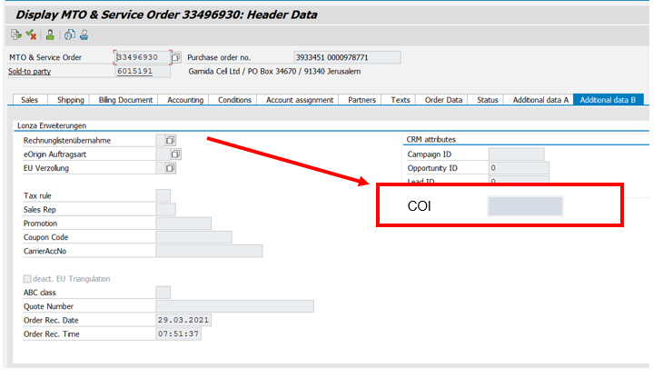
To ensure data is correctly maintained, the check is also performed when saving the sales order, with similar behavior.

Checksum
When the user populates or changes the COI, the checksum is performed and the calculation result, two digits, is displayed to the user via pop-up, so that the user can validate the entered COI:

“Checksum for COI <#####> is <XXX>. Do you confirm?”
Options “Yes” and “No” should be given.
If the user selects “No”, the COI field is made blank again.

For details on the COI checksum calculation refer for the 3way-check Functional Specification.

Sales Order Custom batch determination

Trigger for the batch determination at sales order

The batch determination is triggered by the user (from the menu or button) and the user needs to select the batch from a list of batches that are displayed according to the sort rule. The enhancement for the COI search strategy is triggered if the field ZCOI is not empty.

After the system finds the right batch number, it should be automatically populated in VBAP_CHARG.

Batch search strategy

System checks if ZCOI is empty, if not then the system searches for the batches that have this COI number in the characteristic COI (023 batch class PRODZUST). The batches are listed to the user for selection considering:

- Batches with the sales order COI,
- Expiry date (closest first),
- Receipt date (oldest first).

Retrieve the list of batches (CHARG) with the sales order CO from the ZQM_BATCHCOI table:
ZQM_BATCHCOI-MATNR = VBAP-MATNR
ZQM_BATCHCOI-ZCOI = VBAK-ZCOI

Batches to be retrieved must have stock.

Final check on order save

On sales order save, if batches were entered, the program checks that the batch (CHARG) COI (023 batch class PRODZUST, characteristic COI) matches the sales order COI (ZCOI). If the COI does not match, an error message is displayed.

Delivery creation

When creating a delivery from a sales order the system copies the assigned batch (VBAK-CHARG) automatically to the delivery via the standard control copy.

The batch in the delivery cannot be changed without changing first the batch in the sales order.

The delivery batch will automatically be transferred to the Transfer Order (WM) and this will be the batch that will be picked for the outbound process.

Error Handling Specifications

“Material #### requires a COI ID to be maintained under Header Data, Additional data B tab.”
“Batch #### COI ID is different from the order COI ID. Please assign a valid batch.”
“Checksum cannot be calculated. Ensure the COI ID entered is correct.” (warning)

Related Documents

Document Name | Description
GROUP-117818 | URS SAP ERP Project Alpha Patient Material Chain of identity
GROUP-589 | XS SAP ERP VE Sales and Distribution / Logistics Execution

Document History

Ver # | Date | Author | Brief Description of change
1.0 | 29-Aug-2022 | Paulo Pimenta, Ana Severiano | Initial version

Appendix

N/A

